Microchip Assignment - Reports & Tutorials

Atmel Studio 7 Installation

AS7 studio installation needs certain windows updates like C-Runtime and other packages. There were some issue faced in updating the update packages and resolved using package analyzer tool and were able to update the packages needed for AS7 and completed the installation with Tera Term Tool.
Snippets
AS7 with ASF V3.33.0 version
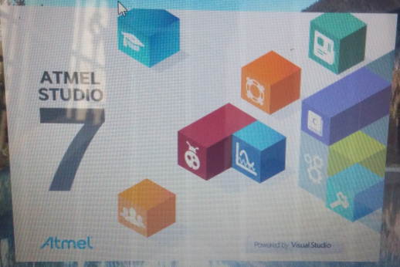
Tera Term Tool
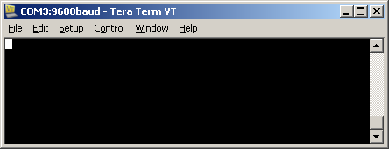

SAM4S Project Creation

There were number of projects around 1000+ shown in the wizard to select the board project, so was not clear with which one go about and tried with few Xplained pro project. But was not suitable for OLED as well as Terminal, Quickly studied and found the Starter it demo was more suitable to use for this purpose.

Interfacing the OLED1 and Project Coding
Checked the SAM4S hardware and understood with the ports and terminal signs to connect the daughter boards to the SAM4S main board. Powered up and checked the connection was made ok and the LEDs were powered up correctly.
With help of the ASF Wizard SAM4S_DIS_UART_PRJ was created for the target hardware ATSAM4SD32C board. Created one header file “oled_uart_ph.h” for declarations and header inclusions then coded the functions needed for all the requirements inside the “main.c” code file.
File Structure:
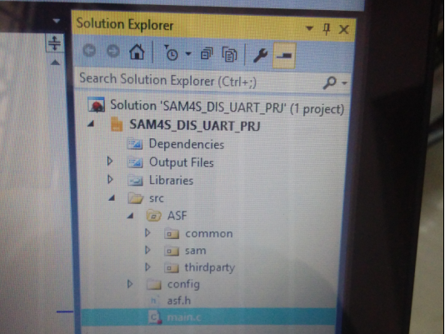

User Menu Selection and Task Flow

Use the “BUTTON 1” in the OLED1 board to select the task and continue to experiment it. Once done move to the next task by pressing the button 1 again. The below snapshot shows different tasks in the OLED1 screen and details will be printed to the terminal screen as well for the user inputs.

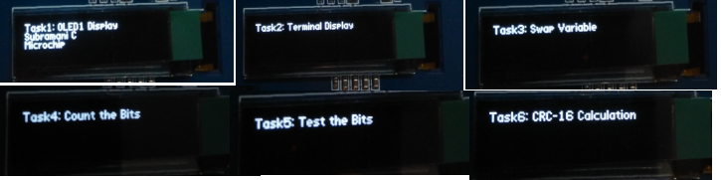

Start and press Button 1
Task 1 will be selected
Start and press Button 1
Task 2 will be selected
Start and press Button 1
Task 3 will be selected

Start and press Button 1
Task 4 will be selected
Start and press Button 1
Task 5 will be selected
Start and press Button 1
Task 5 will be selected

TASK 01 Report and Snapshots

Display your Name and Company name “Microchip” at the startup time in the OLED1 Display connected in the hardware.
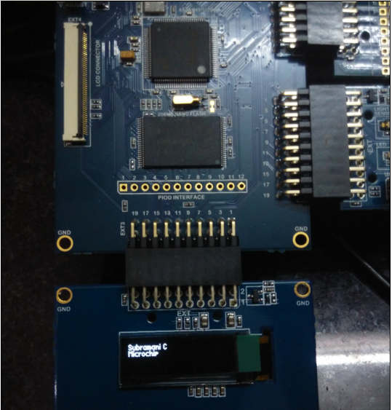
OLED1 Zoomed Snap:
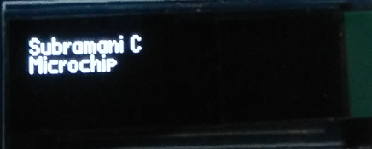

TASK 02 Report and Snapshots

Using debug option break at the code which displays your Name and Company name “Microchip” at the startup time in the OLED1 Display connected in the hardware. AS7 snapshot with break point on the C Variable OLED1_Disp_Name
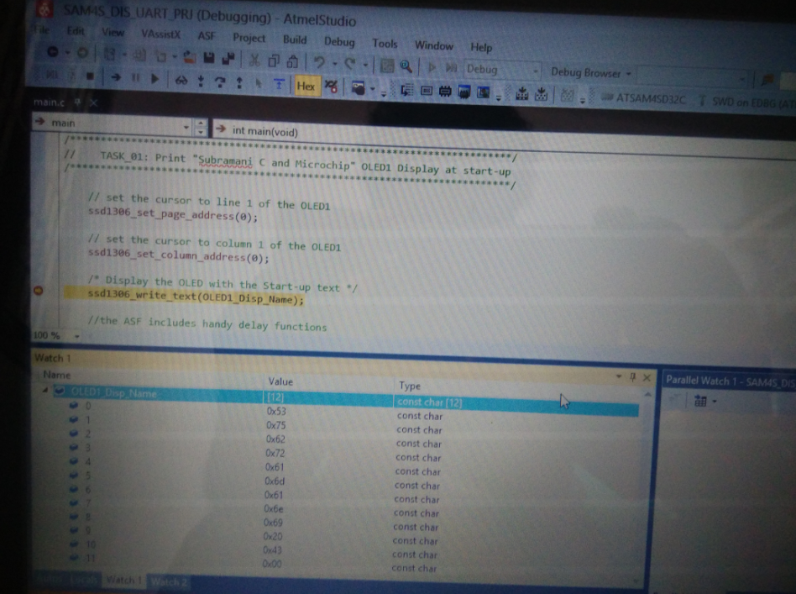

TASK 03 Report and Snapshots

Bring up the firmware in Atmel Studio and output your name to the terminal window through the EDBG port of the development board. Tera Term Terminal snapshot which shows the name and company name printed.
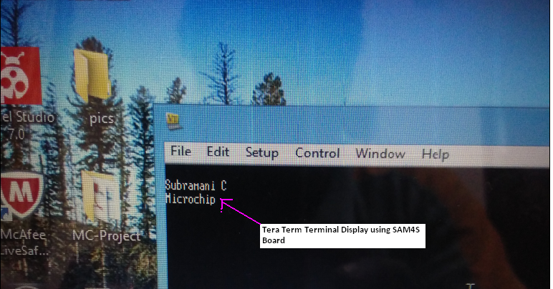

TASK 04 Report and Snapshots

a). write a function that can swap two variables without using an intermediate variable, output test results to terminal window. Function static void Swap_Variable_Task(void) Implements the swapping of variable using XOR technique of two variables. The terminal read will accept only the number and other alphabets while the input is read.

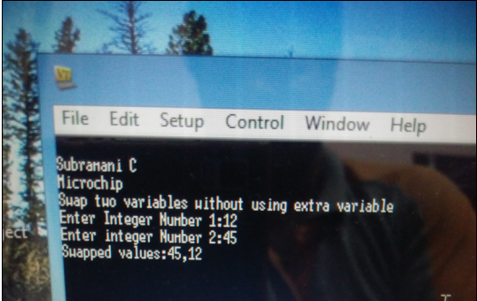

TASK 05 Report and Snapshots

Write a function that will count the number of bits set in a byte, output test results to terminal window. The C function void Count_Num_Bits_Task(void) will accept 1 byte number from the terminal and counts how many bits are set in the input value and display the results to the terminal window. Here is the screen shot shows the results.

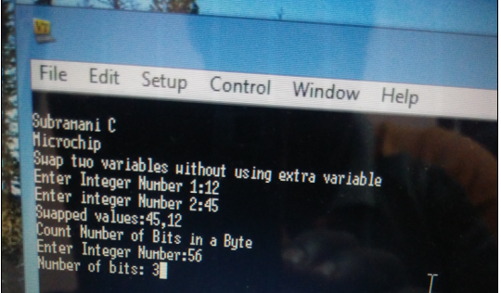

TASK 06 Report and Snapshots

Write a function that takes a 32 bit word, a bit index (nth bit), tests to see if the nth bit is set, returns result, output test results to terminal window. Function void Test_Bit_Task(void)
reads the 32bit input from the terminal and position to test then finds the position is set or not and prints the results to the terminal window.

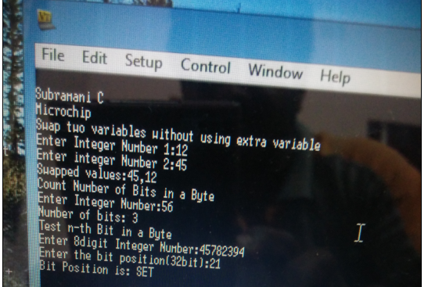

TASK 07 Report and Snapshots

Write your own firmware application on the SAM4S and submit the Atmel Studio solution.
Extra, extra credit if the firmware is crypto related. I wrote the CRC-16 function to calculate the CRC-16 for the input byte array from terminal and printed the CRC-16 value back to terminal window as below.

